
Temperature Sensing
Product Catalogue
Professional · Quality · Innovation
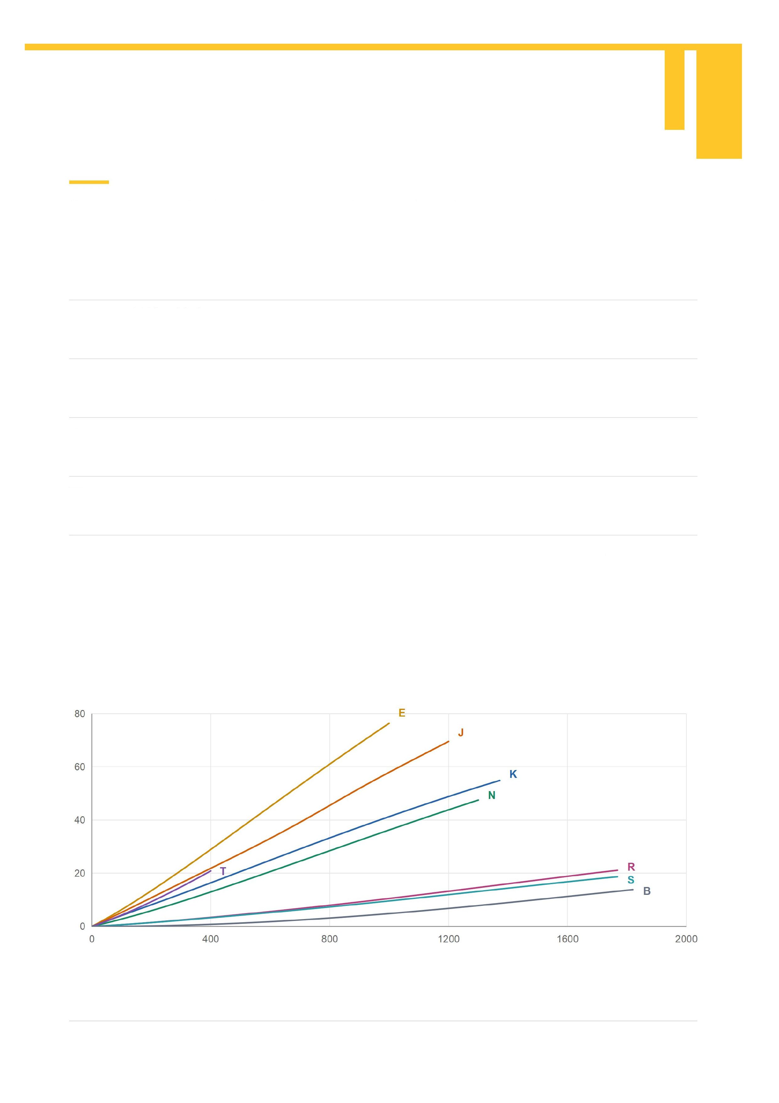
Thermocouple Fundamentals
A thermocouple uses two different conductors to measure temperature through the thermoelectric effect. Thermocouple types have
different EMF outputs and operating conditions; reference-junction temperature compensation is required.
Common Thermocouple Types
K NiCr / NiSi
E NiCr / constantan
J Iron / copper-nickel
T Copper / constantan
N NiCrSi / NiSiMg
Wide range and good oxidation resistance; widely used in furnaces, heat treatment and
process measurement. Protect in reducing atmospheres.
High EMF output for sensitive measurement. Suitable for oxidizing or inert atmospheres
and low temperatures.
General industrial use. The iron leg can rust in damp conditions; protect it in
high-temperature oxidizing atmospheres.
Good low-temperature stability for low and cryogenic temperatures. Use suitable
protection for prolonged service.
Good high-temperature oxidation resistance and long-term stability. Select for the
atmosphere and protective construction.
Thermocouple EMF and Temperature
EMF / mV
Temperature / °C
Reference junction: 0°C. Curves use NIST ITS-90 reference functions and show non-negative temperatures only. Curve endpoints are not product ratings; service limits depend
on wire diameter, sheath material, atmosphere and installation.
Changzhou OSK Special Cable Co., Ltd.

Contents
We develop and manufacture precision temperature
sensing and heating products. Advanced technology,
strict quality control and comprehensive service
support reliable, stable solutions for metallurgy,
chemicals, energy, aerospace, laboratories and
automation, helping customers operate efficiently,
safely and sustainably.
About Us
Quality Assurance
Applications and Delivery
Principles and Products
Temperature Data and Fine MI
Special Thermocouples
Miniature Heaters
Metals and Special Materials
Thermocouple Wire
Platinum RTDs
Instruments and Accessories
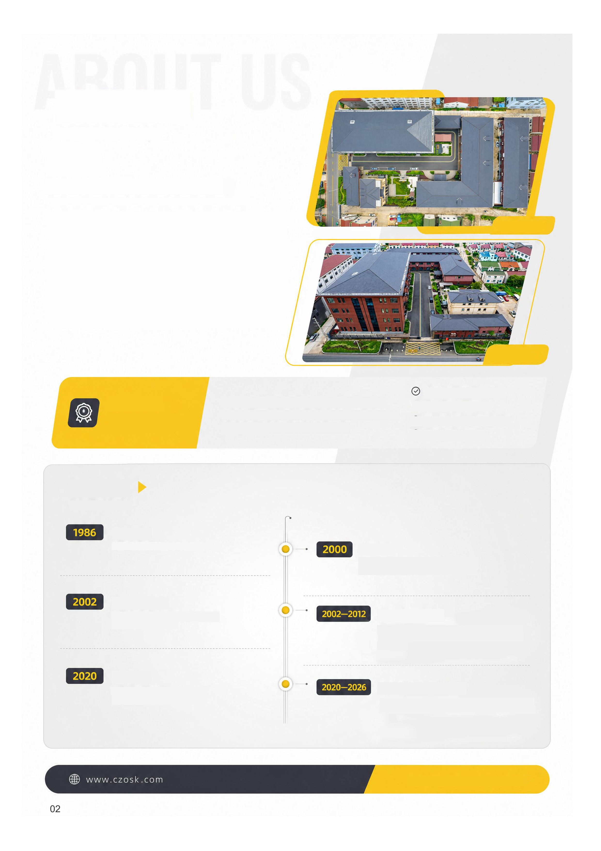
About Us
Changzhou OSK Special Cable Co., Ltd.
Established in the 1980s as the former Xinhe Special Wire Factory in
Lucheng, Changzhou, we have over 40 years of experience in special
mineral insulation and precision thermocouples.
Decades of development have built an integrated factory covering MI stock
drawing, high-density insulation filling, custom structural design and
finished thermocouple production.
We serve demanding supply chains in semiconductor process control,
medical devices, aerospace, defense research and advanced chemicals,
where temperature, insulation and pressure performance are critical.
Factory aerial view
Factory building
Why OSK
Independent R&D, standardized management, supplier
qualifications and technical patents support our role as a
qualified supplier to defense organizations, universities and
multinational manufacturers.
Independent R&D and patents
Qualified defense supplier
University and multinational supplier
Certified quality management
Milestones
Company founded
Focus on temperature sensing and specialized
measurement products.
Production line built
Our first independently developed MI line enabled
in-house, scaled thermocouple production.
Sales channels expanded
Online sales launched, with improved company
structure, sales channels and customer service.
Supplier partnerships expanded
Supplied PLA Factory 6456, Xi’an Jiaotong University,
AVIC and AECC for research, aerospace, defense and
advanced equipment.
Capacity expanded
Factory expansion improved production scale,
delivery efficiency and custom manufacturing.
Stable supply across industries
Supplied the Beijing Institute of Satellite Environment
Engineering, NUDT and other customers in defense,
aerospace, semiconductors, medical devices and new
energy.
Temperature sensing for advanced manufacturing

Company Overview
Core capabilities
Products and focus
Technology and processes
Quality and service
• In-house design and manufacture of MI wire drawing and precision
annealing lines.
• High-density MgO filling for uniform, stable insulation.
• An in-house laboratory with high-voltage insulation tests, X-ray inspection
and precision electrical test systems.
• Fine-diameter MI materials with heat resistance, fast response and strong
interference resistance.
• Multiple drawing specifications, sheath materials and precision
fine-diameter MI thermocouples.
• Semiconductor, precision sensing and new-energy equipment
applications.
• Fine-wire drawing with mature processes and tight dimensional accuracy.
• Fine thermocouples for fast, accurate measurement.
• Custom thermocouples and parts for special conditions.
• Nickel-clad copper balances conductivity, heat and oxidation resistance for
cost-sensitive electrical uses.
• Industrial sensing wire for complex environments.
• Standardized production throughout, with products meeting international
standards.
• Core products used in aerospace, semiconductors, medical devices and
precision manufacturing.
• Technical support and custom solutions.
• Continuous improvements for demanding global markets.
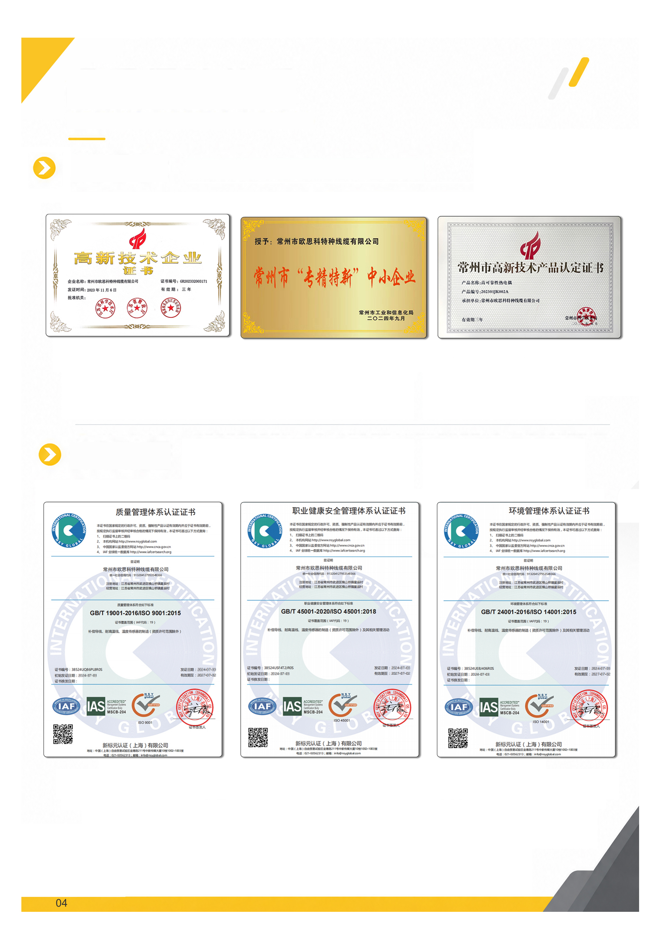
Quality Assurance
Quality as our foundation Innovation as our drive Customer focus
Awards and Qualifications
High-tech enterprise certificate
Specialized and innovative SME
Management System Certification
Quality management
Occupational health and safety
High-tech product certificate
Environmental management
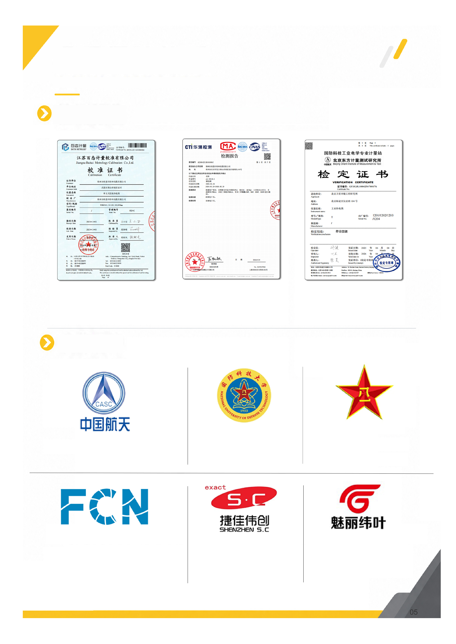
Quality Assurance
Quality as our foundation Innovation as our drive Customer focus
Test Reports
Calibration certificate
Test report
Verification certificate
Selected Customers
Beijing Institute of Satellite
Environment Engineering
National University of
Defense Technology
PLA Factory 6456
Forcecon Technology Co., Ltd.
Shenzhen S.C New Energy
Technology Corporation
Shanghai Meili Weiye
Medical Technology Co., Ltd.
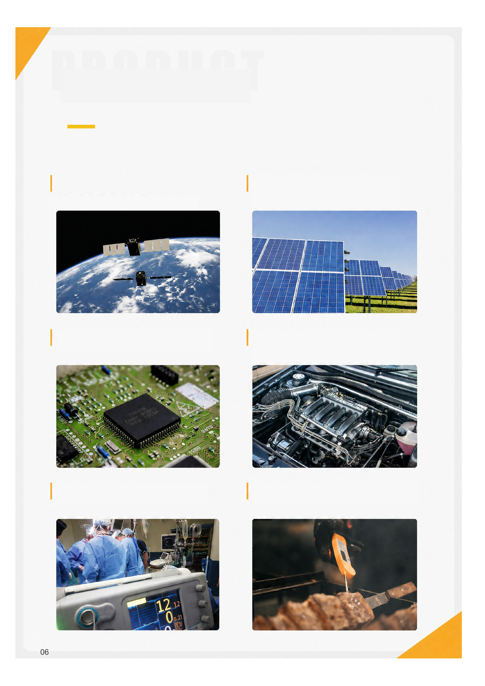
Product Applications
Precision temperature measurement and signal transmission for demanding industrial applications requiring heat resistance,
accuracy, fast response and interference resistance, supported by an agile supply chain.
Aerospace and Power
For extreme temperature differences and vibration.
New Energy and Photovoltaics
Precision sensing throughout battery and PV production.
Semiconductors and Precision Manufacturing
Temperature control for chips and precision instruments.
Automotive and Transport
Thermal management for engines and new-energy powertrains.
Medical and Life Sciences
Sensitive sensing for minimally invasive procedures and devices.
Industry and Food Processing
Food-grade probes and industrial temperature sensing.
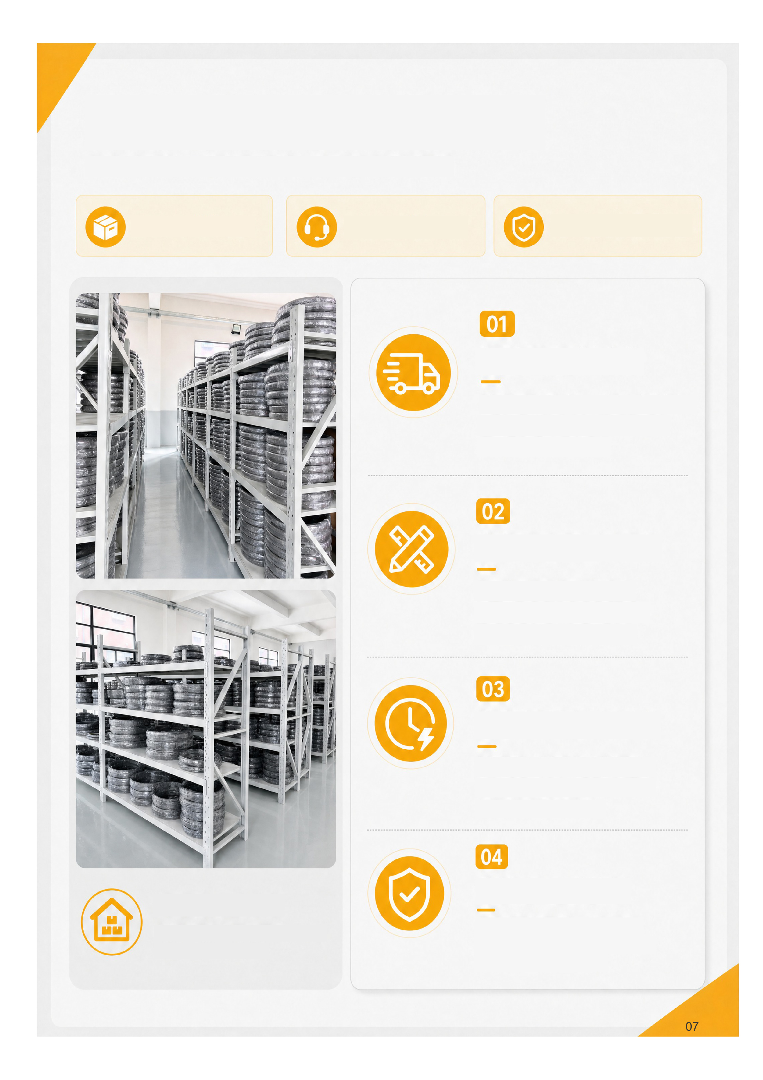
Inventory and Delivery
Stock: dispatch in 24 h
Assessment: reply in 24 h
100% final inspection
Fast Stock Dispatch
Standard products held in stock with systematic
inventory control. Dispatch within 24 hours after
order confirmation helps keep production
running.
Efficient Custom Orders
Our technical team assesses requirements
promptly. Flexible scheduling and supply-chain
coordination support on-time custom delivery.
Priority for Urgent Orders
Priority handling and dedicated follow-up
shorten lead times and respond quickly to
urgent requirements.
Quality at Every Stage
Strict inspection from raw materials to finished
products, including 100% final inspection,
supports reliable product quality.
Managed Warehouse
Zoned storage · ample stock · first in, first out
Accurate inventory and efficient turnover
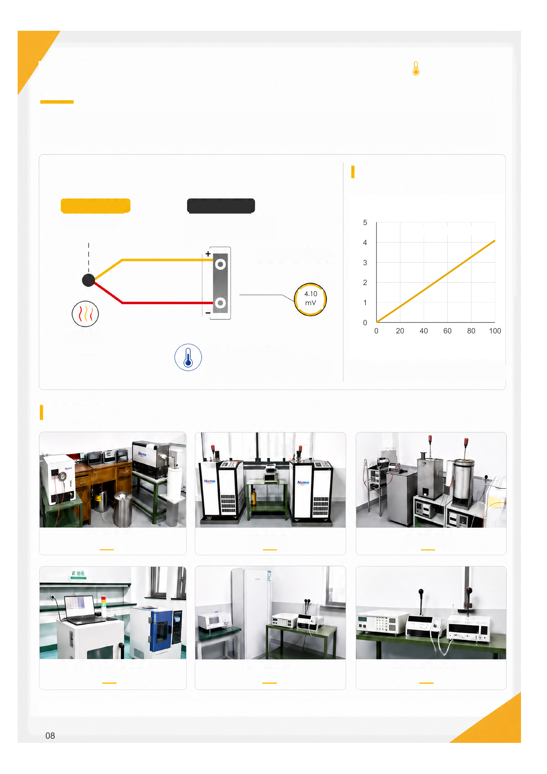
How a Thermocouple Works
Temperature sensing solutions
A thermocouple uses two dissimilar metal conductors. A temperature difference between the measuring and reference junctions
generates an EMF. The instrument calculates temperature from this voltage and the reference-junction temperature using cold-junction
compensation.
Operating principle
Measuring (hot)
Two different metal wires
join at the measuring end.
Temperature and Voltage
Voltage (mV)
Reference (cold)
Instrument-terminal temperature
must be known or measured.
EMF output
Small voltage generated by
the
temperature difference.
Measured temperature
Hot junction
100°C
Reference temperature (cold junction)
0°C in this example; actual instruments
provide cold-junction compensation.
Temperature (°C)
Type K; reference 0°C; approximately 4.10 mV at 100°C
Test Equipment
High-temperature calibration furnace
Constant-temperature oil bath
Dry-well calibrator
Microfocus X-ray inspection system
Insulation resistance tester
Precision temperature logger
100°C ≈ 4.096 mV
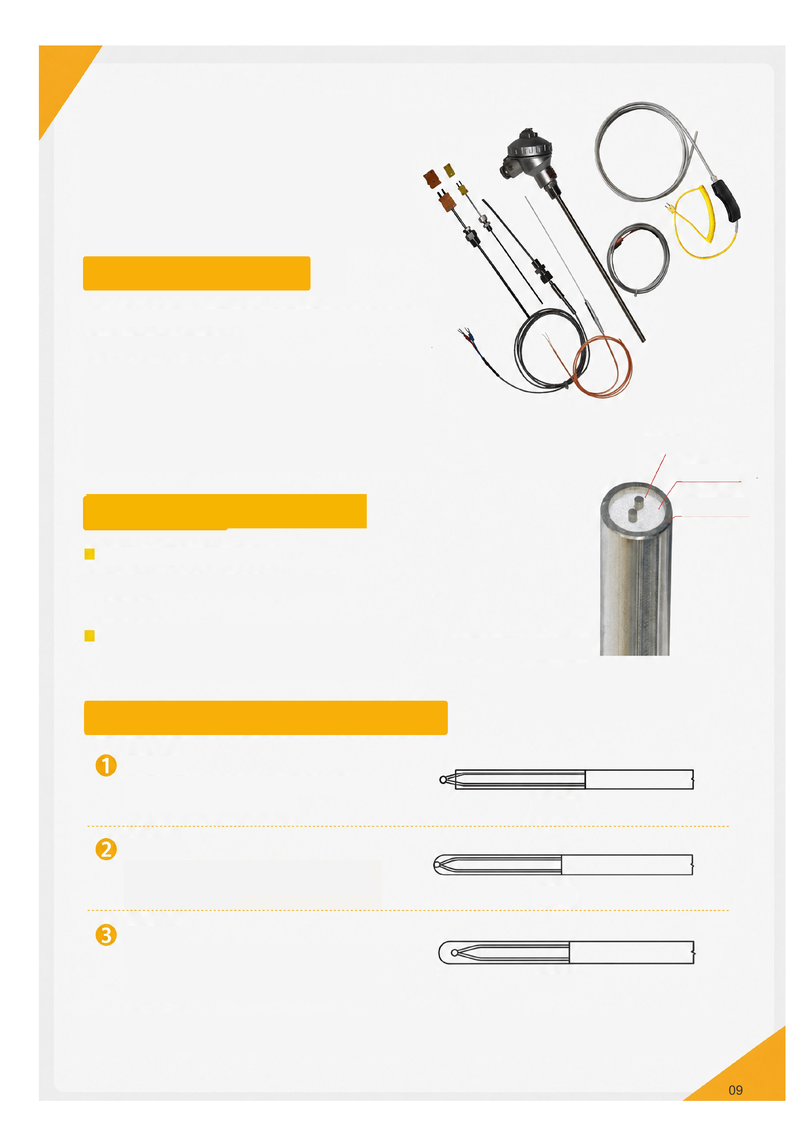
Mineral Insulated
Thermocouples
About MI Thermocouples
An MI thermocouple combines thermocouple conductors, insulation and a
metal sheath into a robust, drawn assembly.
Compact and durable, MI thermocouples work with transmitters,
controllers and displays for process measurement and control.
Service temperature depends on type, sheath, probe and
conditions. A range of 0-1800°C does not apply universally to all MI
thermocouples.
Conductors and Materials
• Thermocouple wire: K, T, J, E, N, R, S, B
• Insulation: alumina or magnesium oxide; MgO is most widely used.
• Sheath: 304, 316L, 310S, Inconel 600,
GH3039, GH3030, Hastelloy and others.
Enlarged MI cross-section
Three Common Junction Types
Exposed junction
Fast response for applications such as engine exhaust;
lower mechanical strength.
Grounded junction
Junction welded to the sheath for fast response.
Assess grounding and noise. Nominal pressure
reference: 34 MPa; confirm by model and conditions.
Ungrounded junction
Electrically isolated from the sheath to reduce
ground-loop and noise effects. Usually slower than an
equivalent grounded junction.
Exposed
Grounded
Ungrounded
TC wire
MgO powder
Metal sheath
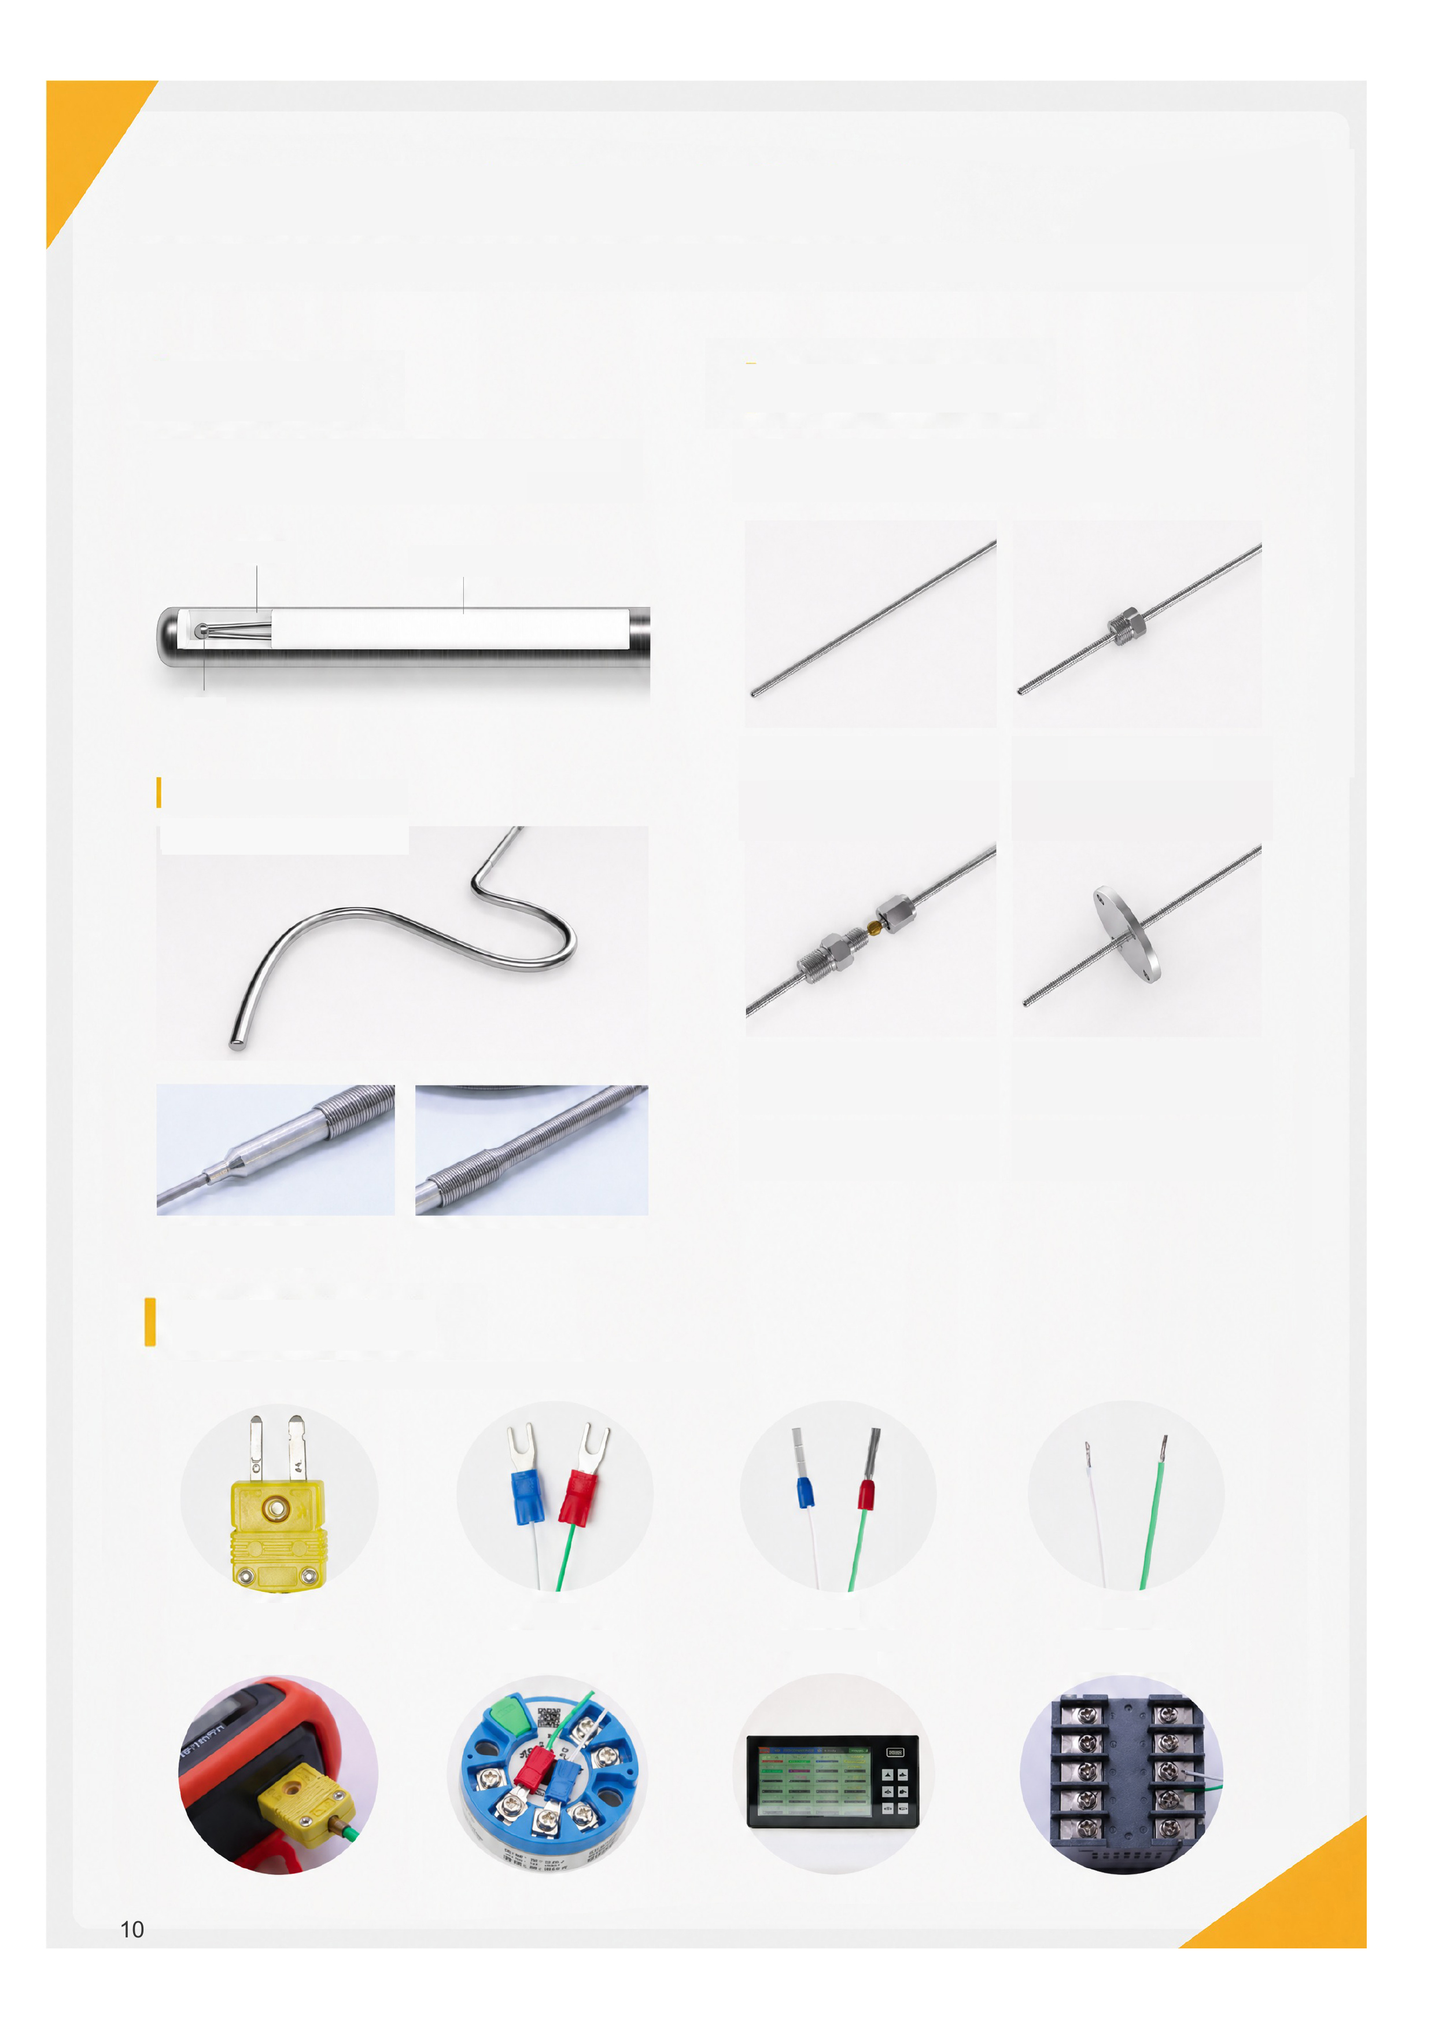
MI Probes and Mounting Options
Conductors, insulation and sheath form a drawn assembly. Bending must meet the requirements of the specific probe construction.
MI Probe Construction
Thermocouple conductors, insulation-grade MgO and a metal
sheath form one assembly; shape to the specified minimum
bend radius.
Metal sheath
Insulation-grade MgO
Mounting Options
No fixed fitting, fixed thread, adjustable compression fitting or flange.
Select mounting position and sealing for the operating conditions.
Conductor
Probe may be formed as specified
Reference bend radius ≥3D
No fixed fitting
Convenient for spot
measurement.
Fixed thread
Custom thread; fixed position.
Compression fitting
Adjustable insertion depth;
custom thread and ferrule.
Flange
Fixed, sealed mounting; custom
flange size.
Default probe: 6 × 40 mm;
custom sizes available.
Flexible strain relief protects the lead.
Electrical Terminations
Available MI thermocouple types can use plugs, terminals, pins or bare leads with compatible measuring instruments.
Plug
Portable instruments
Terminals
Transmitters and controllers
Pins
Recorders and PLCs
Bare leads
Transmitters and controllers
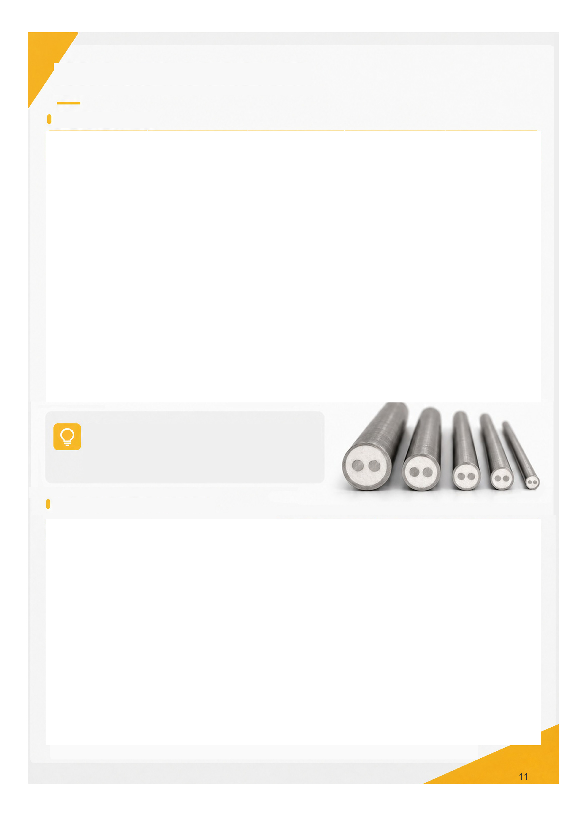
MI Thermocouple Thermal Response Reference
Thermal Response Time
Notes
1. Boiling-water tests; values are response-time references.
2. Confirm t50 / t63.2 / t90, immersion and flow conditions in the test report.
3. For equivalent structures, smaller diameters and grounded junctions usually
respond faster.
MI Probe Diameter and Test Parameters
Confirm AC/DC test format, duration and acceptance criteria against the product test specification.
MI outside  diameter mm | Grounded  response s | Ungrounded  response s | Temperature  step °C | Test  conditions
0.25 | 0.007 | 0.012 | Ambient to 100 | Boiling water
0.5 | 0.027 | 0.031 | Ambient to 100 | Boiling water
0.5 | 0.030 | 0.050 | Ambient to 100 | Boiling water
1.0 | 0.077 | 0.117 | Ambient to 100 | Boiling water
1.0 | 0.070 | 0.120 | 0 to 100 | Boiling water
1.6 | 0.150 | 0.200 | 0 to 100 | Boiling water
1.6 | 0.180 | 0.260 | Ambient to 100 | Boiling water
2.3 | 0.260 | 0.410 | Ambient to 100 | Boiling water
3.2 | 0.400 | 0.500 | 0 to 100 | Boiling water
3.2 | 0.460 | 0.900 | Ambient to 100 | Boiling water
4.8 | 0.730 | 1.200 | 0 to 100 | Boiling water
4.8 | 1.600 | 2.400 | Ambient to 100 | Boiling water
6.4 | 1.200 | 2.400 | 0 to 100 | Boiling water
6.4 | 2.200 | 3.700 | Ambient to 100 | Boiling water
8.0 | 2.100 | 3.900 | 0 to 100 | Boiling water
8.0 | 4.000 | 5.800 | Ambient to 100 | Boiling water

Outside diameter  D mm | Diameter tolerance  mm | Withstand test  V | Reference bend  radius
0.5 | ±0.025 | 100 | ≥3D
1.0 | ±0.025 | 100 | ≥3D
1.5 | ±0.025 | 100 | ≥3D
2.0 | ±0.025 | 500 | ≥3D
3.0 | ±0.030 | 500 | ≥3D
3.2 | ±0.032 | 500 | ≥3D
4.0 | ±0.040 | 500 | ≥3D
4.5 | ±0.045 | 500 | ≥3D
4.8 | ±0.048 | 500 | ≥3D
6.0 | ±0.060 | 500 | ≥3D
6.4 | ±0.064 | 500 | ≥3D
8.0 | ±0.080 | 500 | ≥3D
9.5 | ±0.095 | 500 | ≥3D
10.8 | ±0.108 | 500 | ≥3D


Recommended MI Thermocouple Temperatures
Unit: °C
Notes
1. Recommended values for conventional conditions, for selection reference only.
2. Actual limits depend on sheath, atmosphere, corrosiveness, installation and required life.
3. High-temperature Types S, R and B generally use alumina or ceramic tubes; a direct metal-sheathed MI
construction is generally not recommended.
Sheath Material Temperature Reference
Unit: °C
Notes
1. Conventional material reference values, rather than complete-probe ratings.
2. Confirm continuous or short-term temperature and grade; consider atmosphere, corrosion and life.
3. Verify the specific product limits for high temperature, severe corrosion, vibration or special atmospheres.
Type | Ø0.25-0.5 mm | Ø1.0 mm | Ø1.5-3.0 mm | Ø4.5-6.0 mm
T | 350 | 350 | 350 | 350
J | 500 | 650 | 750 | 750
E | 500 | 700 | 850 | 900
K | 500 | 700 | 900 | 1,100
N | 500 | 700 | 1,000 | 1,200

Sheath | Ø0.25-0.5 mm | Ø1.0 mm | Ø1.5-3.0 mm | Ø4.5-6.0 mm
304 | 500 | 700 | 800 | 900
316L | 500 | 700 | 800 | 900
310S | 500 | 800 | 950 | 1,100
Inconel 600 | 500 | 700 | 1,050 | 1,150
GH3039 | 700 | 900 | 1,100 | 1,200
Hastelloy | 500 | 700 | 900 | 1,000

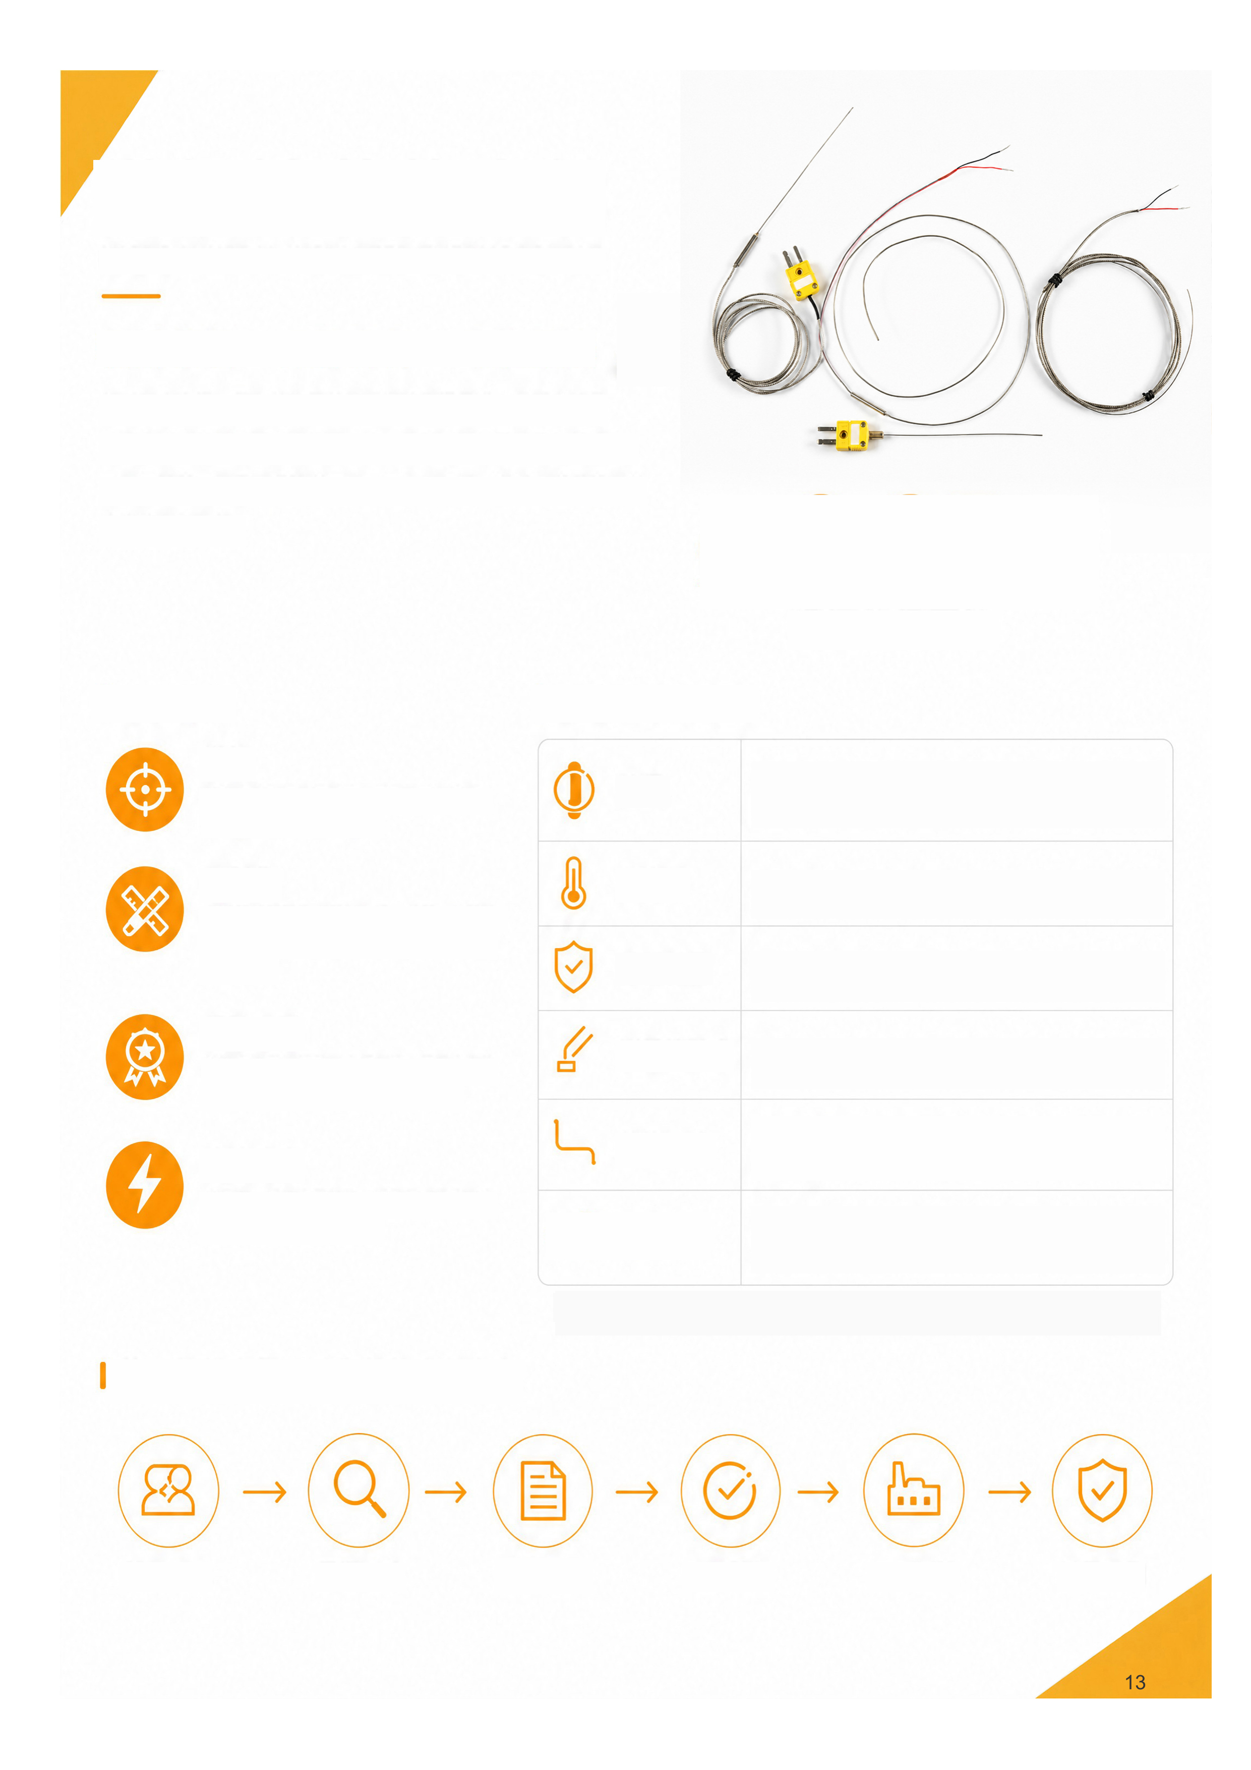
Fine-Diameter
MI Thermocouples
Fine diameters · Custom designs · Dedicated manufacture
We develop and manufacture fine-diameter MI thermocouples for
confined spaces, complex structures and special conditions. Our
product-development and production experience supports custom
dimensions, construction and connections for your application and
installation.
Ø0.25 mm
Outside diameter down to
Key Advantages
Fine diameters
For confined spaces, precision equipment
and complex installations.
Custom manufacture
Custom diameter, length, type, sheath,
junction, shape, mounting and termination.
Manufacturing experience
Long-term expertise in product
development, processing and special
applications.
Fast response
Small dimensions and low thermal mass for
rapid temperature measurement.
Custom Options
Confirm available combinations of diameter, type and sheath for the specific model.
From a Thermocouple to a Complete Custom Solution
Requirements
Application analysis
Design
Sample approval
Production
Final inspection
Diameter
Ø0.25 / 0.5 / 0.8 / 1.0 / 1.5 / 2.0 mm ...
Type
K / J / E / T / N / S / R / B
Sheath
SUS304 / SUS316 / 310S / Inconel ...
Junction
Grounded / ungrounded / exposed / special
Construction
Straight / bent / preformed / threaded / compression /
special
Termination
High-temperature leads / compensating cable /
standard or miniature connectors / custom
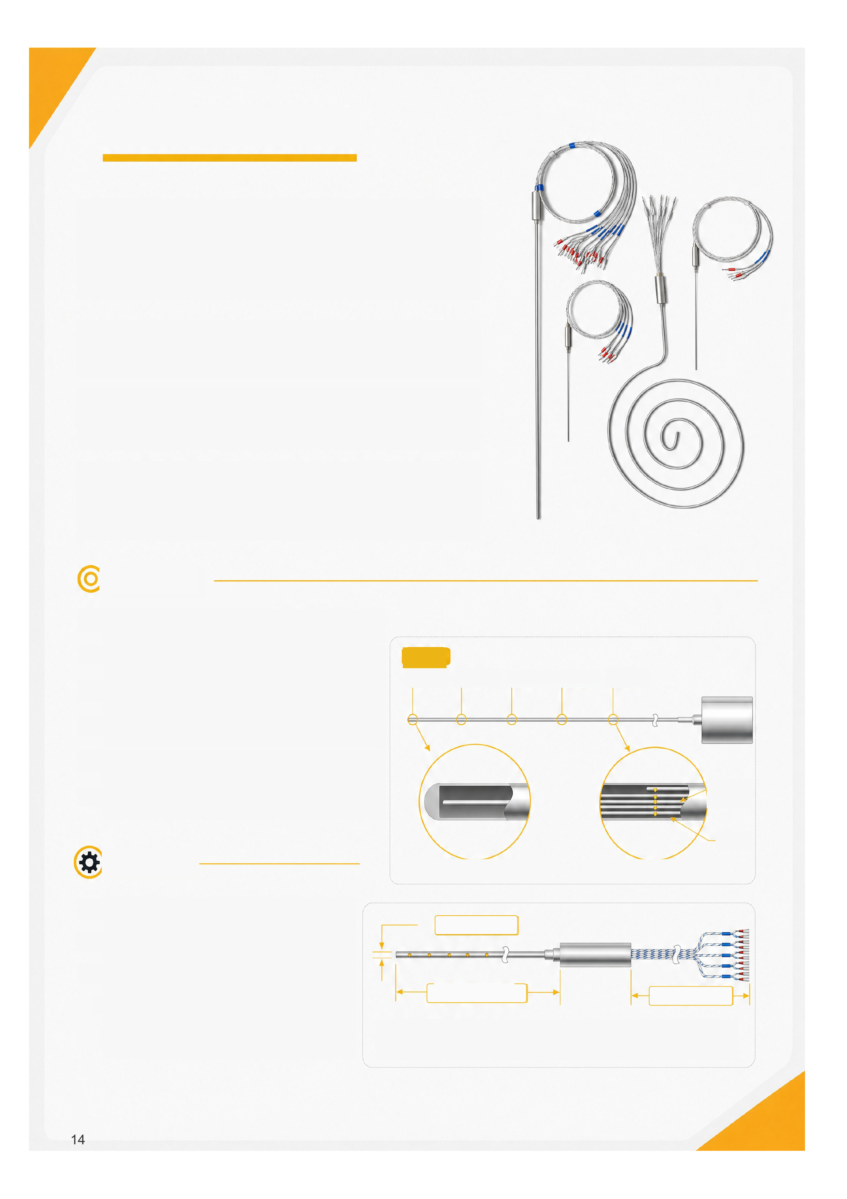
Multipoint Thermocouples
Multipoint thermocouples measure several positions within one area.
Multiple sensing points are integrated into a protection tube or assembly
with different lengths and positions, for monitoring temperature distribution,
gradients and critical process points.
They collect more temperature data in limited space, reduce vessel
penetrations and simplify installation for more complete monitoring.
Sensing-point count and spacing, tube material, wiring and mounting can
be customized for high temperature, high pressure, corrosion and wear.
Used in reactors, tanks, towers, furnaces, piping, chemical plants and
power systems to support operating monitoring, process optimization,
safety interlocks and fault diagnosis.
Features
• Multiple points in one sensor to monitor temperature
distribution.
• Fewer equipment penetrations and simpler installation
and maintenance.
• Custom point count, position and length.
• Types K, J, E, N and T available.
• Tube materials for heat, corrosion and wear.
• Stable output for continuous process measurement.
Applications
• Temperature profiles in chemical reactors.
• Different heights in tanks and silos.
• Furnace and heat-treatment zones.
• Critical points in piping, towers and pressure
vessels.
• Power, metallurgy and petrochemical processes.
Measuring points
Point 1
Point 2
Point 3
Point 5
Single-point arrangement
Tube outside diameter
Protection tube length L1
L1: protection tube length excluding leads.
L2: lead length from the connection to the terminal end.
Type K MI
thermocouple
Protection tube
Multipoint arrangement
Lead length L2
Point 4
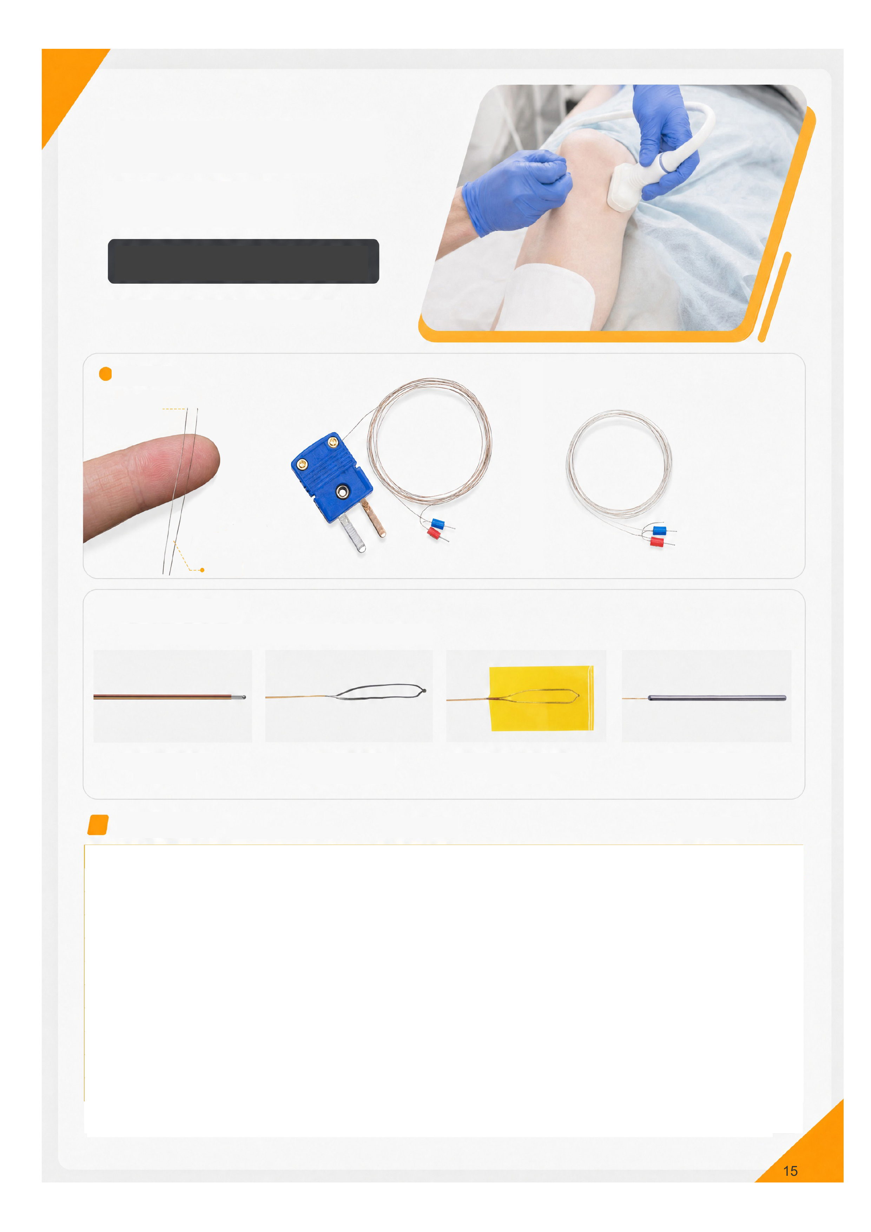
Ultrafine Thermocouple Wire
Hair-fine conductors
Surface sensing in small spaces
Minimally invasive procedures, electronic chips and lithium batteries
Thermocouple wire
Sensing wire
Connectors
Hair
Probe Options
Welded junction, foil, adhesive foil and small-tube probes for different temperature measurements.
Welded junction
Very small spaces
Foil
Surfaces or narrow gaps
Adhesive foil
Surface temperature
Small metal tube
Liquids or internal temperatures
Specifications
Sensing wire
Connectors
* Confirm the insulation grade and corresponding temperature range for the operating conditions. Under IEC 60584-1, Type T Class 1 tolerance applies from -40 to 260°C;
lower-temperature tolerances are specified separately.
Parameter | Type K ultrafine wire | Type T ultrafine wire
Type | K | T
Insulation | Polyesterimide / polyimide / polyester | Polyesterimide / polyimide / polyester
Temperature* | -20 to 200°C / -20 to 260°C | -200 to 200°C / -200 to 260°C
Tolerance | Class 1 | Class 1
Conductors | NiCr (+) / NiSi (-) | Copper (+) / constantan (-)
Conductor diameter | 0.05-0.2 mm | 0.05-0.2 mm
Overall diameter | Custom | Custom
Enamel thickness | Custom | Custom
Enamel color | Custom | Custom
Termination | Custom | Custom

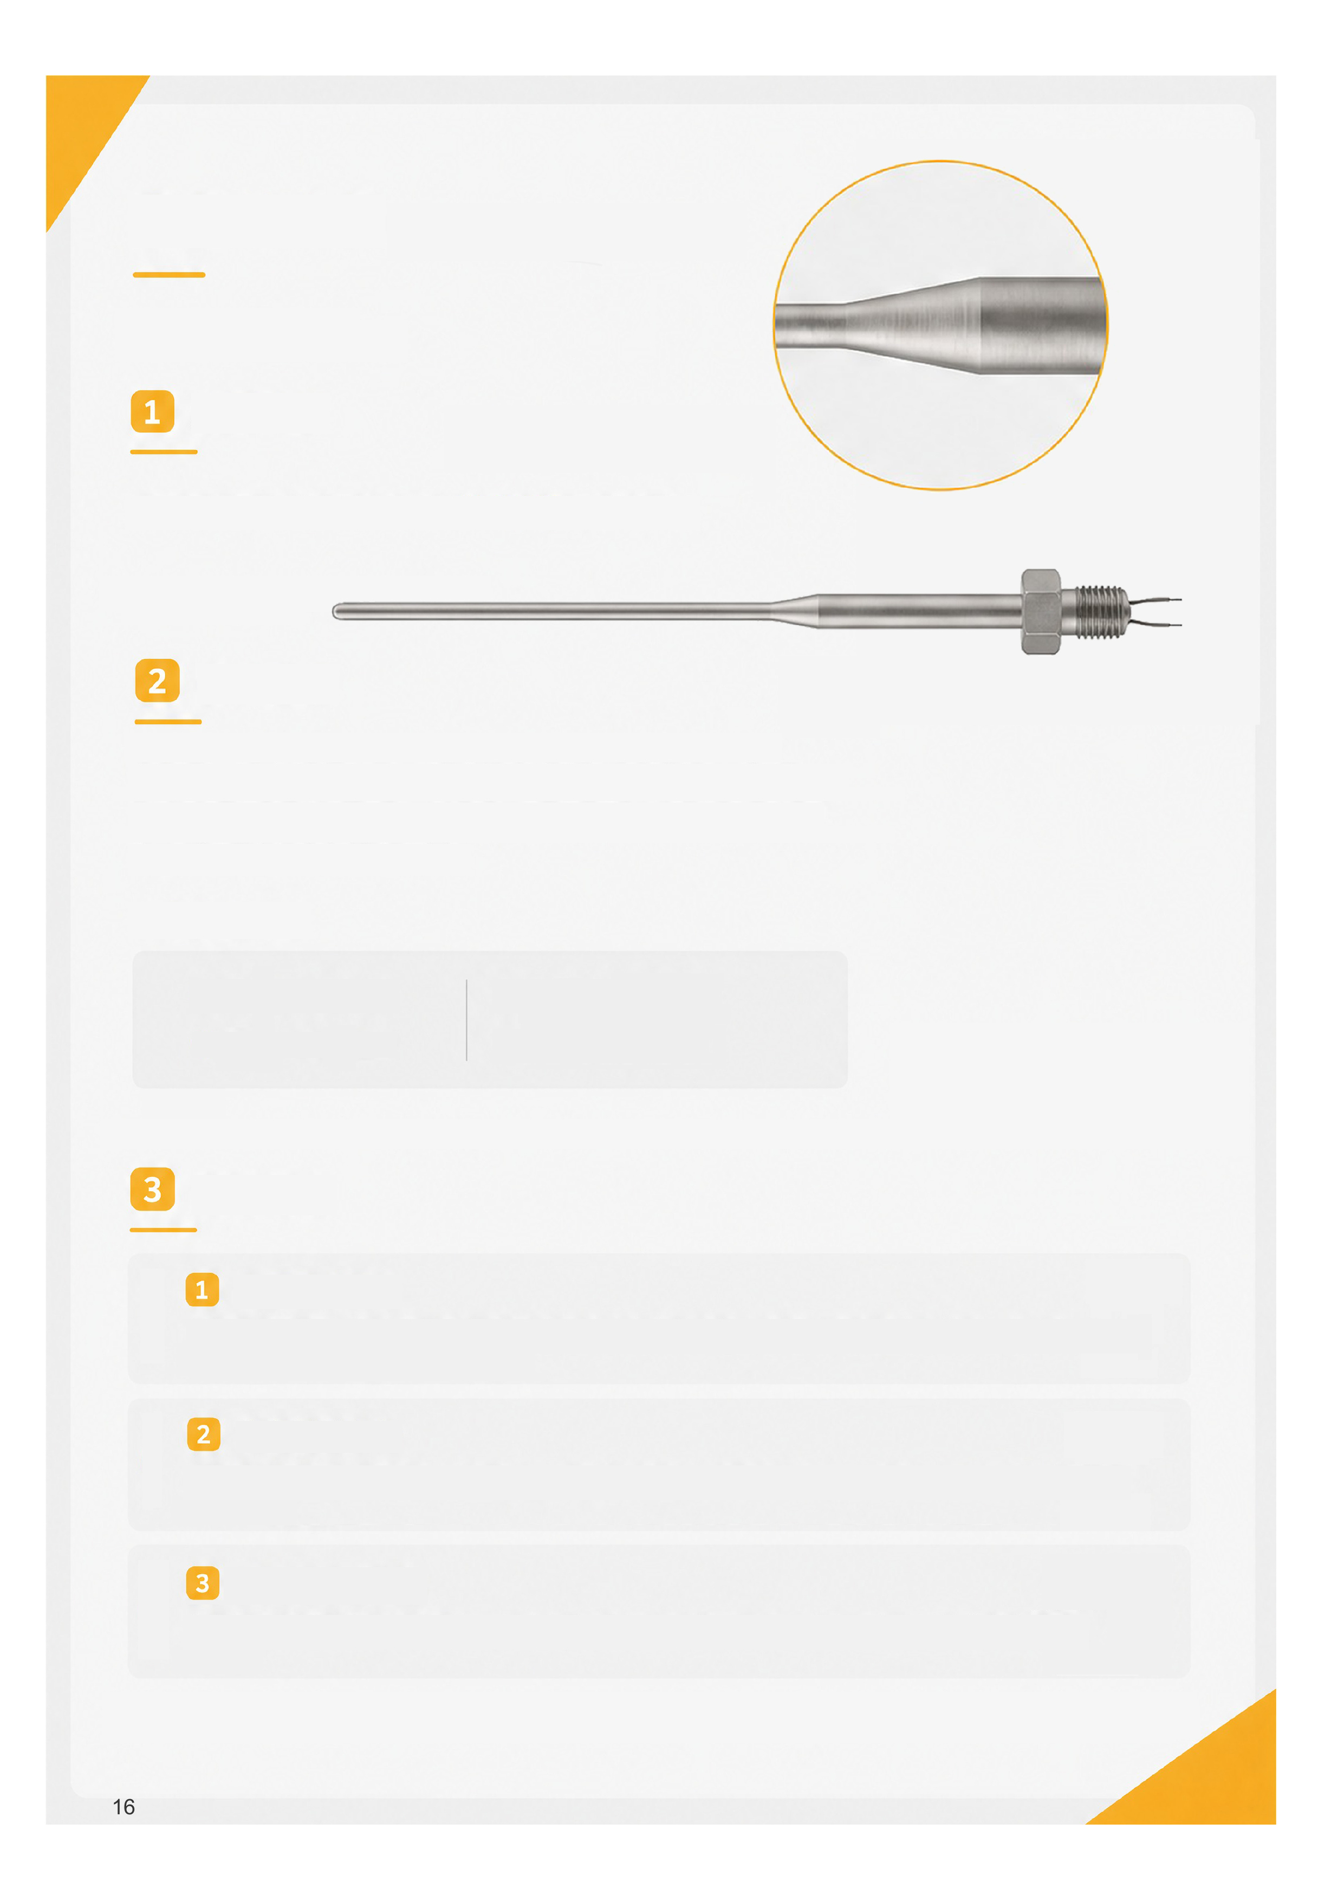
Reduced-Tip Thermocouples
Applications
Temperature measurement in limited space while maintaining mechanical strength.
Manufacturing Principle
Local reduction of the sensing end uses plastic deformation to compress the sheath, MgO
insulation and thermocouple conductors together. It forms a continuous, uniform reduced
section while keeping the internal structure intact and preventing conductor breakage or
insulation failure.
Typical reductions
• Ø3.2 to Ø2.3 mm
• Ø6 to Ø3.2 mm
• Ø4.8 to Ø1.6 mm
• Ø3.0 to Ø1.6 mm
Custom sizes available
Design Considerations
Reduced-tip dimensions
Select body diameter, reduced diameter and reduced length for response time, installation space and
mechanical strength. Balance thermal response with structural strength.
Transition design
Use a smooth radiused or tapered transition to avoid abrupt section changes, reduce stress concentration and
improve bending and fatigue performance.
Manufacturability
Keep reduction within process limits to avoid sheath cracking, conductor damage or reduced insulation
performance.
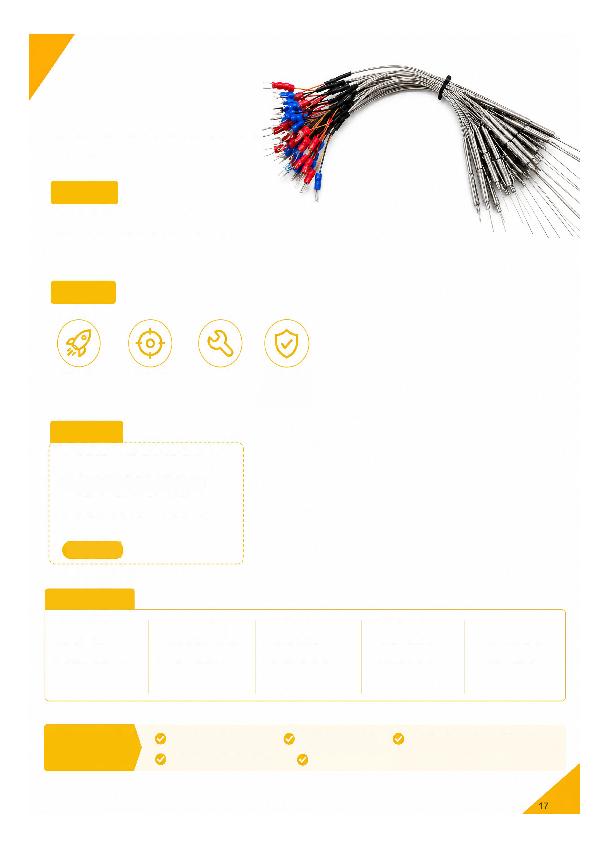
Hot Runner
Thermocouples
1 Application
Temperature measurement in injection-mold hot
runners: nozzles, manifolds, hot tips and
confined spaces inside molds.
2 Features
Fast response
Accurate sensing
Flexible form
Heat stability
Specifications
• Ø0.25 / 0.5 / 0.8 mm
• Ø1.0 / 1.5 / 2.0 mm
• Types K / J / E / T / N
• Straight / bent / preformed
Custom
3 Selection
1 Probe size
Select diameter and
length for the hole
size and depth.
2 Tip structure
Select for response
speed and
installation.
3 Mounting
Select for available
space and lead
routing.
4 Connection
Select for cable
distance and
environment.
5 Materials
Select for
temperature and
service conditions.
Product Highlights
Fine probes for small spaces
Precision sensing for stable control
Flexible installation
Heat stability and
durability
For nozzles, manifolds, hot tips and mold
interiors

Miniature MI Heaters
Miniature mineral insulated heaters combine a heating element, insulation and
metal sheath through precision processing. Their compact, reliable structure
offers efficient heat transfer and fast response for uniform heating in confined
installation spaces.
Mechanical strength, high-temperature resistance and long-term stability suit
precision heating with demanding size, response and control requirements. Various
structures and custom designs support different equipment and operating conditions.
Features
Compact design
Flexible installation in space-limited equipment.
Robust construction
Reliable MI construction resists vibration and shock.
Fast response
Close element-to-sheath contact improves heat
transfer for rapid heat-up.
Stable control
For precision temperature control and continuous
heating.
Applications
Semiconductor equipment, analytical and test instruments, medical devices, precision molds, hot runners, automation, laboratories and
other processes requiring rapid heating and stable control.
Parameter | Options
Sheath outside diameter | Ø0.5 / 1.0 / 1.5 / 2.0 / 3.0 / 4.0 / 5.0 / 6.0 mm; custom
Sheath material | SUS304 / SUS316L / SUS321 / SUS310S / Inconel 600, etc.
Heating wire | Cr20Ni80 (NiCr80/20) / iron-chromium-aluminum (FeCrAl)
Insulation | High-purity magnesium oxide (MgO)
Lead arrangement | Single-ended or double-ended; custom
Rated voltage | 12 / 24 / 36 / 48 / 110 / 220 / 380 V or custom
Power | Custom
Heated length | Custom
Overall length | Custom
Cold section length | Custom
Lead length | Custom
Lead types | Nickel-plated copper / nickel / fiberglass / silicone / PTFE
Lead exit | Axial / radial / 90° bend / custom
Mounting | Direct insertion / thread / flange / compression fitting
Seal | Epoxy / silicone / ceramic

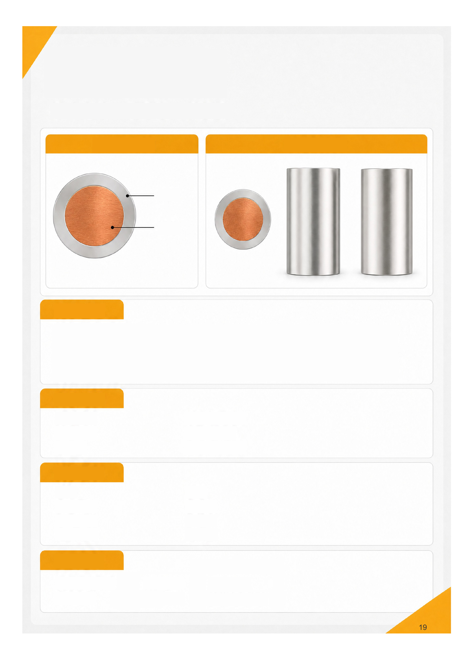
Nickel-Clad
Copper Wire
High conductivity High temperature resistance High strength
Composite construction
Product appearance
Nickel layer
Copper core
Specifications
Material: nickel-clad copper composite wire
Nickel: (30 ± 3)% (confirm the measurement basis in the specification)
Copper core: balance, approximately 67%-73%
Diameter: 0.15-8.0 mm
Features
Low resistivity
High conductivity
Corrosion resistance
High-temperature oxidation resistance
High tensile strength
Strong nickel-to-copper bond
Material advantages
Copper core
High conductivity
Low resistivity
Good ductility
Nickel layer
High-temperature resistance
Oxidation resistance
Corrosion resistance
Applications
Thermocouples and sensing
Automotive systems
High-temperature cables
Industrial equipment
Heating elements
Special electrical connections
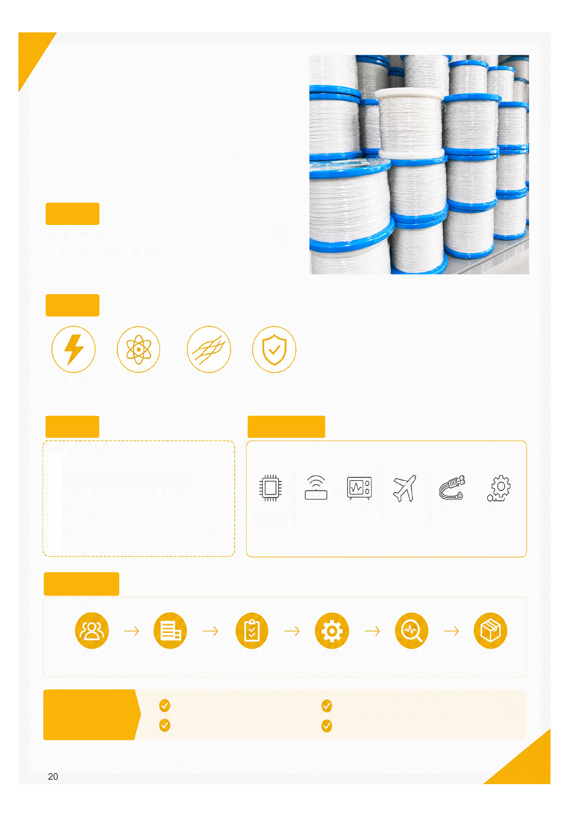
Pure Silver Wire
High purity · High conductivity · Reliable · Custom
1 Application
Electronics, sensors, precision instruments, aerospace,
advanced connections and industrial measurement.
2 Features
Conductivity
High purity
Ductility
Reliability
3 Specs
• Diameter: custom.
• Purity: various silver grades to suit
requirements.
• Conductor: solid, stranded or special.
• Length and packing: cut lengths, spools or
coils.
• Custom designs for temperature, conductivity
and other requirements.
4 Applications
Electronics
Sensors
Precision
Aerospace
Connections
Industry
5 Custom Process
Requirements
Material selection
Specifications
Precision processing
Testing
Delivery
Product Highlights
High-purity silver for excellent conductivity
Good ductility for complex processing
Stable and reliable in diverse applications
Custom manufacture and prompt response
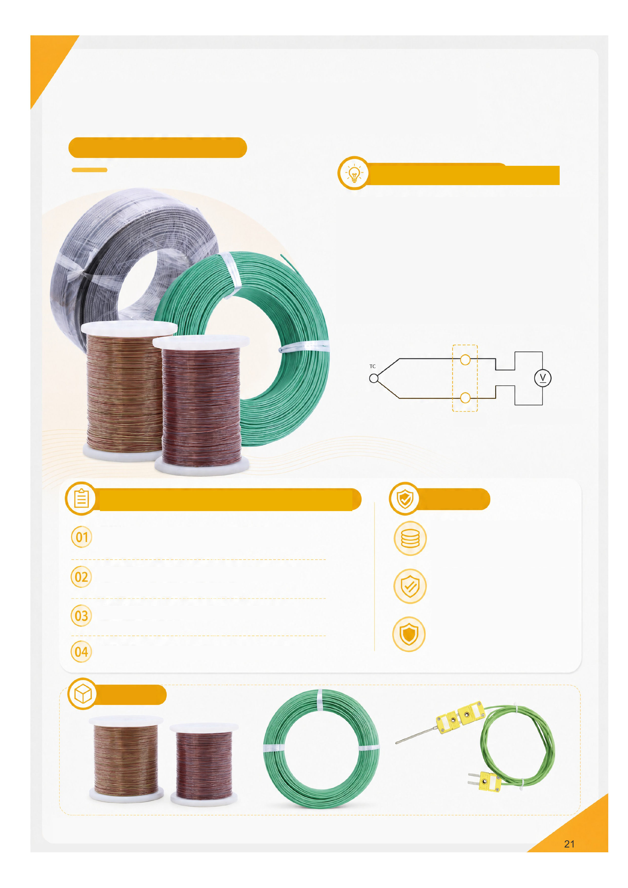
Thermocouple Extension
and Compensating Cable
Types K / T / J / N / R / S and others
Extension vs. Compensating Cable
Extension cable (e.g. KX) uses the same nominal conductor alloys
as its thermocouple. Compensating cable (e.g. KCA/KCB) uses
different alloys with matching thermoelectric characteristics within a
specified temperature range.
Both carry the thermocouple signal to the instrument. Match type,
polarity and temperature range correctly. Cold-junction
compensation is performed by the instrument, rather than
automatically by the cable.
Construction: conductors, insulation, jacket and optional shield.
Metal A
Measuring junction
Instrument
Metal B
Connections
Instrument cold-junction
compensation
Cable Selection and Connection
Match the cable to the thermocouple type for matching
EMF characteristics within the specified range.
Connect the correct polarity. Keep both connection pairs at
the same temperature.
Keep the cable and thermocouple connection within the
specified cable temperature range.
Select conductor diameter for the instrument requirements.
Features
Quality alloys
Stable electrical properties and precise
EMF matching.
Reliable insulation
Heat and abrasion resistance with good
electrical insulation.
Optional shielding
Select for the electromagnetic environment
to reduce noise.
Examples
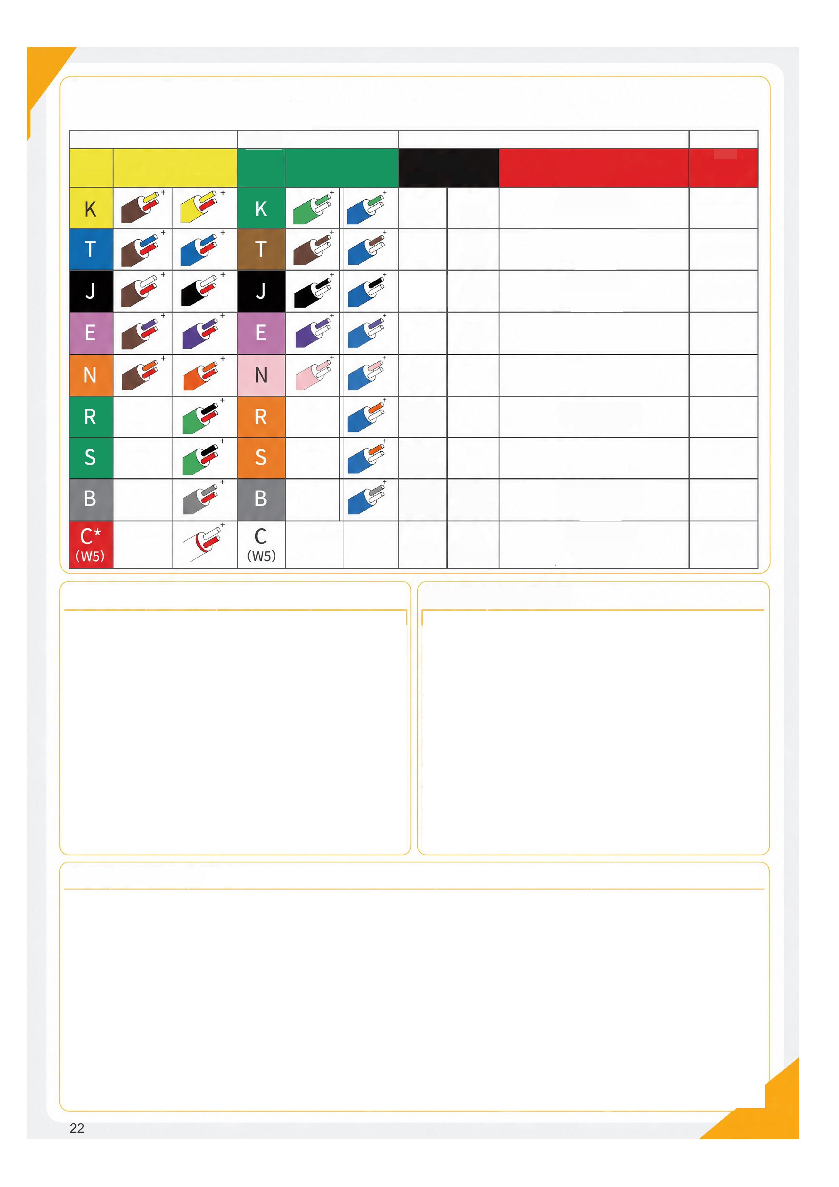
Thermocouple, Cable and Connector Color Codes
KPS · ANSI · IEC
Connectors
Connectors
ANSI
Code
ANSI / ASTM E-230
Color code · TC grade
Ext. grade
IEC
Code
IEC 584-3
Color code · TC
grade
Ext. grade
Undefined
Undefined
Undefined
Undefined
Undefined
Undefined
Undefined
No IEC standard;
use ANSI colors
Alloy pair
Notes
Bare-wire atmosphere
Maximum
TC-grade range
NiCr
NiAl
(magnetic)
Cu
CuNi
constantan
Fe
(magnetic)
CuNi
constantan
NiCr
CuNi
constantan
NiCrSi
NiSiMg
Pt-13Rh
Pt
Pt-10Rh
Pt
Pt-30Rh
Pt-6Rh
W-5Re
W-26Re
Fe
(magnetic)
Clean oxidizing or inert atmospheres; limited vacuum
or reducing use. Wide range; most common type.
Mildly oxidizing, reducing, vacuum or inert. Good in
damp conditions and for low-temperature or
refrigeration use.
Reducing, vacuum or inert atmospheres; limited
high-temperature reducing use. Not recommended
for low temperatures.
Oxidizing or inert; limited vacuum or reducing use.
Highest EMF change per degree.
Alternative to Type K; suited to higher temperatures.
Oxidizing or inert. Avoid metal tubes and
contamination. High-temperature use.
Oxidizing or inert. Avoid metal tubes and
contamination. High-temperature use.
Oxidizing or inert. Avoid metal tubes and
contamination. High-temperature and glass
applications.
Vacuum, inert or hydrogen. Protect from oxidation.
Impractical below 399°C (750°F); unsuitable for
oxidizing atmospheres.
-200 to 1372°C
-270 to 400°C
-210 to 1200°C
-270 to 1000°C
-270 to 1300°C
0 to 1600°C
0 to 1600°C
0 to 1800°C
0 to 2320°C
Insulation and Jacket Temperature References
Customization Options
Thermocouple Type and Application Reference
+ leg
- leg
Material | Range °C | Features | Applications
PVC | 70-105 | Low cost; flexible | Ambient instruments;  cabinet wiring
Silicone | 180-200 | Flexible; bend and  thermal-shock resistance | Heaters; molds; moving  connections
PTFE | 200-260 | Heat, chemical and  insulation performance | Chemical; semiconductor;  precision equipment
PFA | 200-260 | Chemical resistance;  smooth and clean | Semiconductor; medical;  clean equipment
Fiberglass | 350-500 | Heat and aging resistance | Ovens; furnaces; heat  treatment
Fiberglass + shield | 350-400 | EMI, abrasion and heat  resistance | Industrial furnaces; strong  EMI
Ceramic fiber | 600-1000 | High heat resistance; lower  flexibility | Furnaces; kilns; hot zones
Quartz fiber | 500-800 | Heat and thermal-shock  resistance | High-temperature and  heat-treatment furnaces

Parameter | Available options
Conductor | Solid / stranded
Core count | 2 / 4 / 6 / 8 / custom multicore
Diameter | Ø0.2 / 0.3 / 0.5 / 0.8 / 1.0 / 1.2 mm, etc.
Cross-section | 0.2 / 0.3 / 0.5 / 0.75 / 1.0 / 1.5 mm², etc.
Insulation | Single / double layer / insulation plus jacket
Shield | None / tinned copper / stainless braid / foil / overall / individual
Jacket | PVC / silicone / PTFE / PFA / fiberglass / metal braid / ceramic fiber
Color standard | IEC / ANSI / GB / customer specified
Tolerance | Class 1 / Class 2 / special
Packing | Coils / spools / cut lengths / prepared ends

Type | Conductors | Typical cable | Sensor range °C | Main characteristics | Typical applications
K | NiCr / NiSi | K; KX extension; KCA/KCB compensating | -200 to 1260 | Versatile; widely used | Heaters; molds; furnaces; piping; machinery
J | Iron / CuNi | J wire; JX extension | -40 to 750 | Common at low/medium temperatures; low  cost | Plastics; packaging; ovens; older controllers
T | Copper / CuNi | T wire; TX extension | -200 to 350 | Good low-temperature stability | Cold chain; laboratories; food; low temperatures
E | NiCr / CuNi | E wire; EX extension | -200 to 900 | High EMF and sensitivity | Laboratories; precision sensing; low-signal uses
N | NiCrSi / NiSiMg | N wire; NX/NC cable | -200 to 1300 | Heat stability; oxidation resistance | Furnaces; heat treatment; aerospace; advanced  equipment
S | Pt-10Rh / Pt | S wire; SC compensating | 0 to 1600 | High accuracy and stability; higher cost | Lab and calibration furnaces; glass; ceramics;  metallurgy
R | Pt-13Rh / Pt | R wire; RC compensating | 0 to 1600 | High-temperature accuracy and stability | Industrial furnaces; laboratories; noble-metal  thermometry
B | Pt-30Rh / Pt-6Rh | B wire; BC compensating | 600 to 1700 | Very high temperatures; low sensitivity at low  temperatures | Metallurgy; glass and ceramic kilns; furnaces

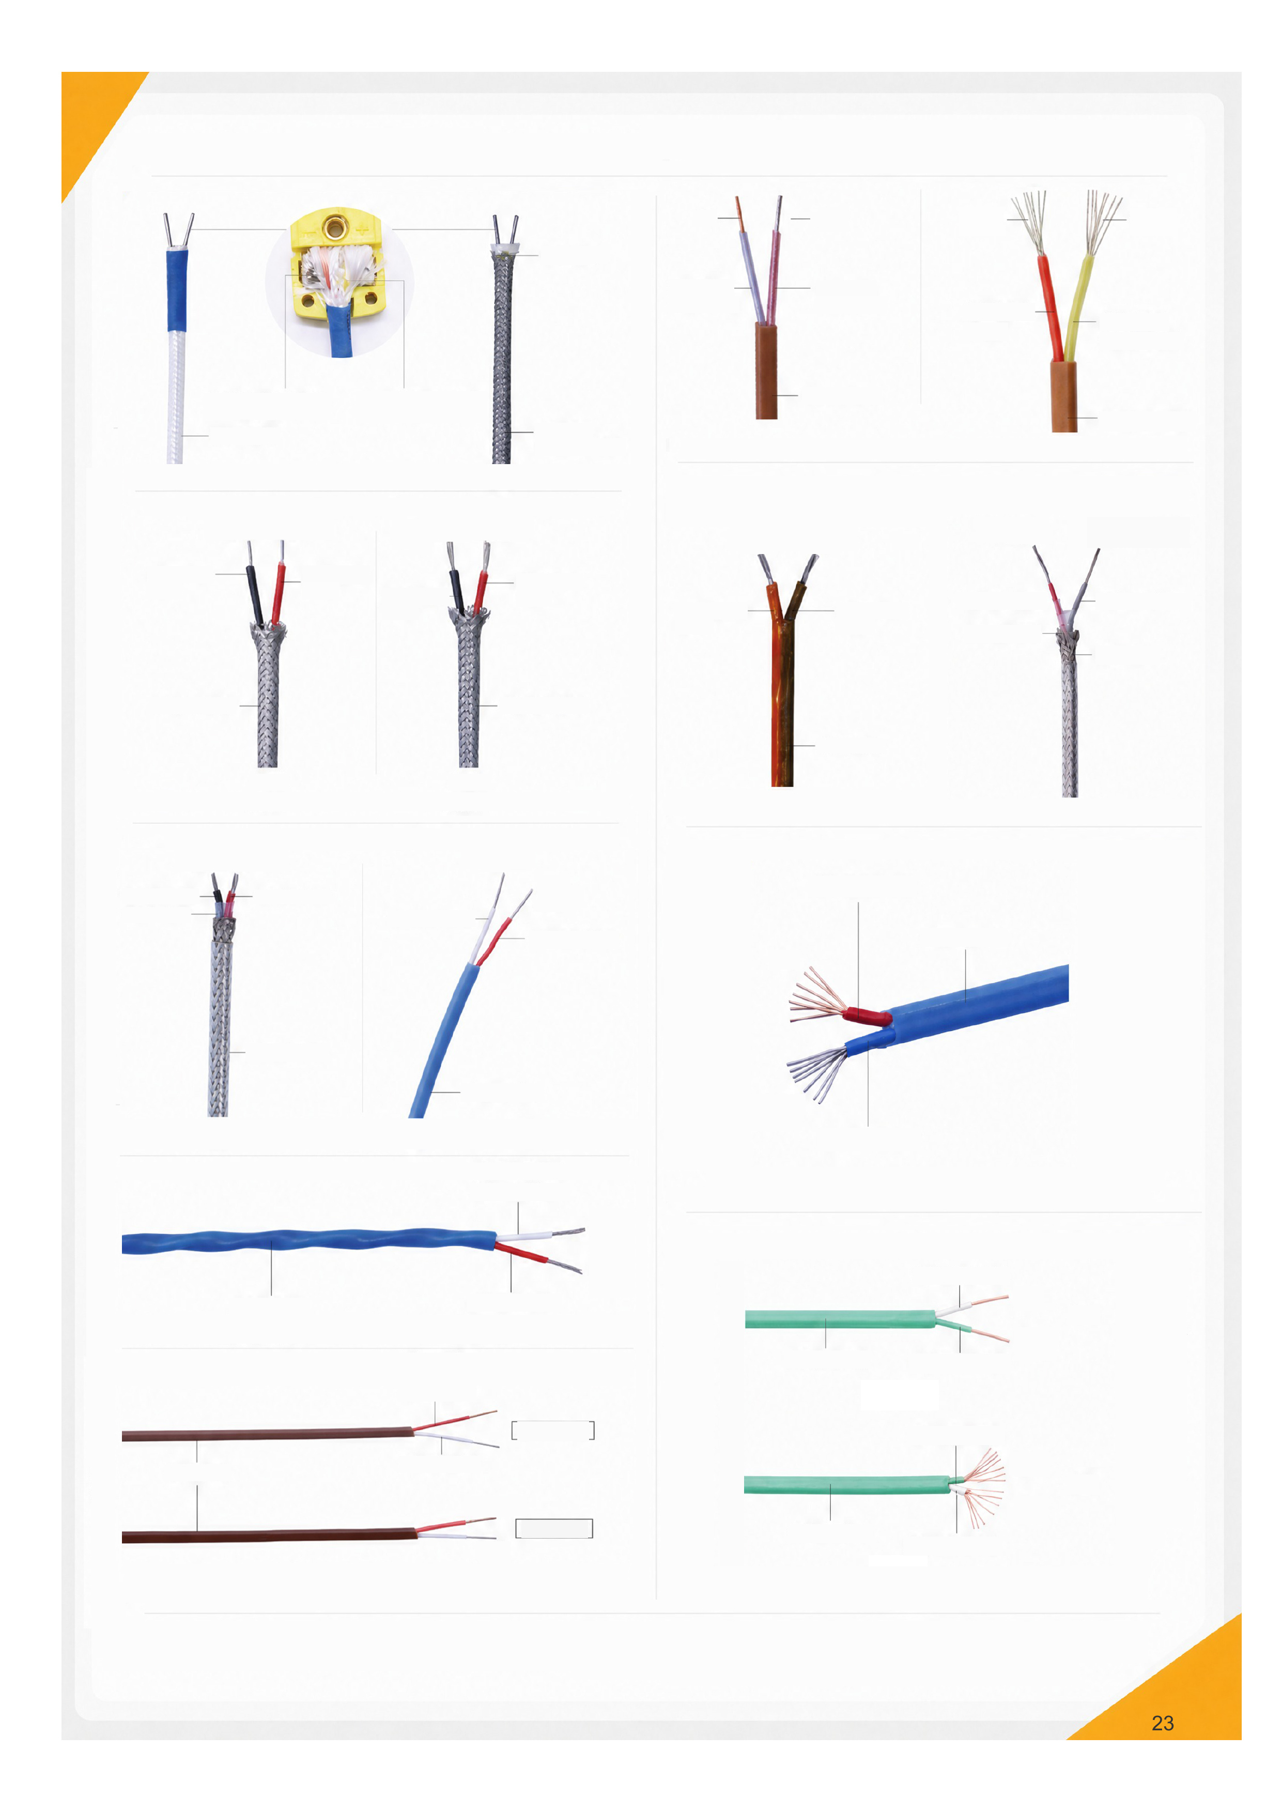
Ceramic fiber
White / red dot: NiAl
White / yellow dot: NiCr
Ceramic-fiber jacket
Metal shield
Prevents fiber
spreading
NiSi (-)
NiCr (+)
NiSi (-)
NiCr (+)
Stainless-steel
shield
Stainless-steel shield
Solid
conductor
Stranded
conductor
Copper (+)
NiCr (+)
Constantan
(-)
Brown PTFE jacket
NiSi (-)
Polyimide jacket
NiAl (-)
NiCrSi (+)
Red PTFE insulation
PTFE film
NiCr (+)
Brown PTFE jacket
NiSiMg (-)
Gray PTFE
insulation
Metal shield
NiSi (-)
NiCr (+)
Black PTFE
insulation
PTFE film
Red PTFE insulation
Clear PTFE jacket
NiAl (-)
NiCr (+)
White PTFE insulation
Red PTFE insulation
Blue PTFE jacket
Red PTFE insulation
Blue PTFE jacket
Copper (+)
Constantan
(-)
Blue PTFE insulation
Blue PTFE jacket
Brown PTFE jacket
White PTFE insulation
Red PTFE insulation
Red PTFE insulation
Wire Ø0.3 mm
White PTFE insulation
Constantan
(-)
Wire Ø0.5 mm
Iron (+)
NiAl (-)
NiCr (+)
Green PTFE jacket
Green PTFE jacket
White PTFE insulation
NiAl (-)
NiCr (+)
Green PTFE
insulation
Green PTFE
insulation
NiCr (+)
NiAl (-)
White PTFE insulation
Solid
Stranded
Black fiberglass
insulation
Red fiberglass
insulation
Black
fiberglass
insulation
Red fiberglass
insulation
Blue
translucent
fluoropolymer
insulation
Brown polyimide
insulation
Red translucent
fluoropolymer
insulation
Black polyimide
insulation
Red fluoropolymer
insulation
Yellow translucent
fluoropolymer
insulation
Fiberglass jacket
White PTFE insulation
Red fiberglass insulation
Red PTFE insulation
Clear PTFE jacket
Brown PTFE jacket
Copper (+)
Constantan (-)
Copper (+)
Constantan (-)
Constantan (-)
Iron (+)
Constantan (-)
Iron (+)
4 cores
Clear PTFE jacket
Silicone jacket
Red PTFE insulation
White PTFE insulation
Red PTFE insulation
White PTFE insulation
Clear PTFE insulation
Red PTFE insulation
Metal shield
Wire: 0.12 mm × 7 × 3
PTFE film
PTFE insulation
Tinned copper
Clear PTFE jacket
Silver-plated shield
OD approx. 2.8 mm
PTFE film
0.15 mm × 7 × 4
6 cores
PTFE jacket
Clear PTFE insulation
Red PTFE insulation
0.15 mm × 7 × 3
PTFE jacket
OD 3 mm
White PTFE insulation
Metal shield
Red PTFE insulation
0.15 mm × 7 × 3
OD 3.3 mm
Dense stainless-steel braid
Fiberglass insulation
OD 3.5 mm
Dense stainless-steel braid
Fiberglass insulation
Unshielded
0.15 mm × 7 × 3
OD 3 mm
0.15 mm × 7 × 4
OD 4 mm
Clear PTFE insulation
0.15 mm × 7 × 3
Red PTFE insulation
0.15 mm × 7 × 6
3 cores
0.2 mm × 7 × 3
4 cores
0.2 mm × 7 × 4
Shielded
0.15 mm × 7 × 3
OD 4 mm
Platinum RTDs
What is an RTD?
A resistance temperature detector (RTD) measures temperature through changes in electrical
resistance. Platinum RTDs offer high accuracy and good long-term stability for industrial processes and
calibration. The actual temperature range and tolerance depend on the element and probe construction.
Three RTD Lead Configurations
2-wire: one lead connects to each end of the platinum element. The reading includes lead resistance,
with error affected by lead length, material and ambient temperature. Suitable for short leads or
measurements that can accept the resulting error.
3-wire: one end has one lead and the other has two. An appropriate measurement circuit and
matched lead resistances reduce the influence of lead resistance. Common in industrial process
measurement.
4-wire: two leads connect to each end. Two provide excitation current and two measure the voltage
across the element (Kelvin connection), substantially reducing lead-resistance error for high-accuracy
measurement.
Platinum RTD Elements
Fast response
Element tolerance options
A, B, 2 × B, 1/3B, 1/10B. Confirm fractional tolerances and
applicable temperature ranges for the specific element.
Pt100 versus Pt1000
1 Resistance sensitivity
For the same temperature coefficient, the change per °C of
Pt1000 is 10 times that of Pt100. For α = 0.00385/°C, averages
over 0-100°C are:
Pt1000: 3.85 Ω/°C
Pt100: 0.385 Ω/°C
Resistance sensitivity is not thermal response speed.
2 Operating temperature
Determined by element construction, probe design and service
conditions, rather than nominal resistance alone.
Pt100 Tolerance Reference
Permissible deviation (±°C)
1/3DIN and 1/10DIN are fractional tolerances. Values are references; confirm the applicable temperature range and test conditions for the specific element.
Temperature °C | Class A | 1/3DIN | 1/10DIN
-100 | 0.35
-50 | 0.25 | 0.18
0 | 0.15 | 0.10 | 0.03
100 | 0.35 | 0.27 | 0.08
200 | 0.55 | 0.43
250 | 0.65 | 0.52
300 | 0.75
350 | 0.85
400 | 0.95
450 | 1.05

Direct-Insertion MI RTDs
Range: -200 to 500°C*
Details
Hexagonal fixing
Secures the probe against slipping or
loosening
304 stainless-steel sheath
316L available
Imported
platinum
element
Three-pin RTD plug with U-type copper contacts
Standard round-pin plugs and custom probe diameters available
Platinum element
Custom probe length
* Confirm temperature range and tolerance for the actual element and probe configuration.
Formable MI Probes
Conductors, insulation and sheath form a drawn MI assembly. Follow the bend radius
for the specific construction and avoid repeated bending. No fixed fitting is standard;
fixed threads or adjustable compression fittings are optional.
Fixed threaded fitting
Adjustable compression
fitting
Cold and heat resistant
Corrosion and wear
resistant
Water and oil resistant
Fast response
Product | Direct-insertion MI RTD | Brand | OSK
Element | Pt100 default / Pt1000 custom | Temperature | -200 to 500°C*
Sheath | 304 stainless steel; 316L optional | Dimensions | Custom diameter and  length
Tolerance | A / B / 1/3B / 1/10B | Application | Furnace and oven sensing

Thermocouple Plugs and Sockets
SMPW Miniature Connectors
Types: N / T / K / R / S / E / J / U / C; M = male, F = female
Temperature: -29 to 180°C (-20 to 356°F)
Features
• Rugged, heat-resistant construction for -29 to 180°C.
• Solid or stranded wire up to 20 AWG.
• Fast connection and reliable contact.
• Wire divider; Phillips/slotted screws.
Structure
Wiring example
N
C
T
K
R / S
E
J
K
J
E
U
U
OSTW Standard Connectors
Types: K / T / J / E / N / R / S / U / C; M = male, F = female
Temperature: -29 to 180°C (-20 to 356°F)
High-Temperature Ceramic Connectors
Miniature and standard ceramic connectors
Temperature: -29 to 650°C (-20 to 1200°F)
Silicone insulation washer
Serrated male
contact
Glass-filled
nylon housing
Terminals
Wire divider
Reversible write-on window
Tapered male contacts
Glass-filled nylon housing
Wire divider
Terminals
Silicone insulation washer
Tapered male contact
Terminals
Color dot
High-purity alumina housing
Features
• Versatile universal design.
• Compact, for wire up to 14 AWG.
• Fast connection and reliable contact.
• Wire divider; Phillips/slotted screws.
Structure
Features
• Ceramic construction: -29 to 650°C reference range.
• Strong, durable ceramic housing.
• Screw terminals for easy wiring.
• Solid or stranded wire up to 20 AWG.
• Phillips/slotted screws.
• Suitable for vacuum furnaces.
Images for reference. Confirm available types, ordering codes and 180°C / 650°C rating conditions for the specific product.
T
C
T
C
N
R / S
Stainless-Steel Compression Fittings
Threads: M / G / ZG / NPT and others
Adjustable TC Fittings
1 Nut
2 Copper ferrule
* Confirm pressure and temperature for the specification and medium; the upper limits do not necessarily apply
simultaneously.
Applications
For MI thermocouples, probe RTDs and platinum-rhodium thermocouples.
Installation Diagram
Thermocouple probe
Mold
Parameter | Specification | Parameter | Specification
Product | Stainless-steel fitting | Brand | OSK
Pressure | 15 MPa* | Temperature | ≤450°C*
Material | 304 default; 316 optional
Media | Water / oil / gas. Check material for corrosive media.
Threads | M / ZG / G / NPT; custom
Probe OD | 0.5 / 1 / 1.5 / 1.6 / 2 / 2.5 / 3 / 3.2 / 4 / 5 / 6 mm ...
Parts | Body / ferrule / nut; custom weld-on base

Precision Temperature Instruments
Thermocouple Thermometers
Platinum RTD Thermometers
Thermocouple Thermometers
Types K / T / J supported
Single / dual / four channels
610: 1 channel
610L: 1 channel with logging
620: 2 channels
620L: 2 channels with logging
640: 4 channels
640L: 4 channels with logging
Probe input
LCD
Multifunction key 1
Switch type / hold reading
Power / backlight
Multifunction key 2
Maximum / minimum / average
Switch °C / °F
Applications
Manufacturing
Research
HVAC
Maintenance
High precision
Multiple sensor types,
accurate measurement
and fast response.
Channel options
Single, dual or four
channels for different
applications.
USB port
Battery
Data logging
Record and review data
for traceability and
analysis.
Rugged design
A slip-resistant, durable
housing for industrial
environments.
Let’s Talk About Your
Temperature Measurement Needs
From operating conditions to product specifications,
we will work with you to confirm each requirement.
Send an application description, drawing or sample
to discuss product selection and customization.
Changzhou OSK Special Cable Co., Ltd.
Contact Us
Mr. Fang +86 13806110632
Mr. Du +86 13806123888
Address: Xingchen Village, Hengshanqiao Town, Changzhou, Jiangsu, China
Website: www.czosk.com
Email: lihua@czosk.com
jiacheng@czosk.com

